Screen 1:

Insert Stella Smith Header

Vitals should show (make dates 8/1/19)

BP: 132/82

Resp: 12

Temp: 99.7 (red / alert)

BS: 199

Pulse: 108

O2: 96%

Weight: empty

Pain: 3

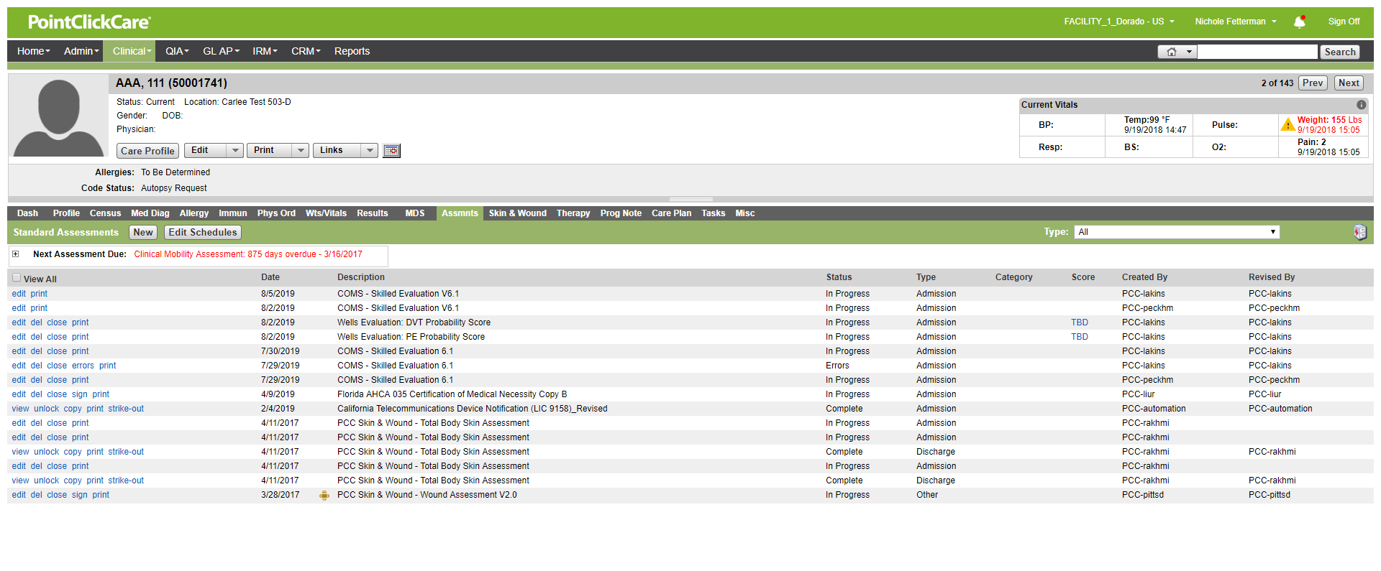

List of assessments below: Should only read

COMS – Skilled Evaluation Complete Full Assessments PCC-Nurse 1 PCC-Nurse 1

COMS – Skilled Evaluation Complete Full Assessments PCC-Nurse 2 PCC-Nurse 2

COMS – Clinical Admission Evaluation Complete Admission PCC-Nurse 3 PCC-Nurse 3

COMS – AIMS Complete Admission PCC-Nurse 3 PCC-Nurse 3

COMS – Braden Scale for Predicting Pressure Ulcer Risk Admission Very High Risk 6.0 PCC-Nurse 3 PCC-Nurse 3

COMS – Fall Risk Evaluation Complete Admission PCC-Nurse 3 PCC-Nurse 3

COMS – Nestle’s Mini Nutrition Evaluation Complete Admission PCC-Nurse 3 PCC-Nurse 3

COMS – Resident Preferences Evaluation Complete Admission PCC-Nurse 3 PCC-Nurse 3

When I click in area – add red box around alert icon

Screen 2:

Lay it over the page you built for screen 1

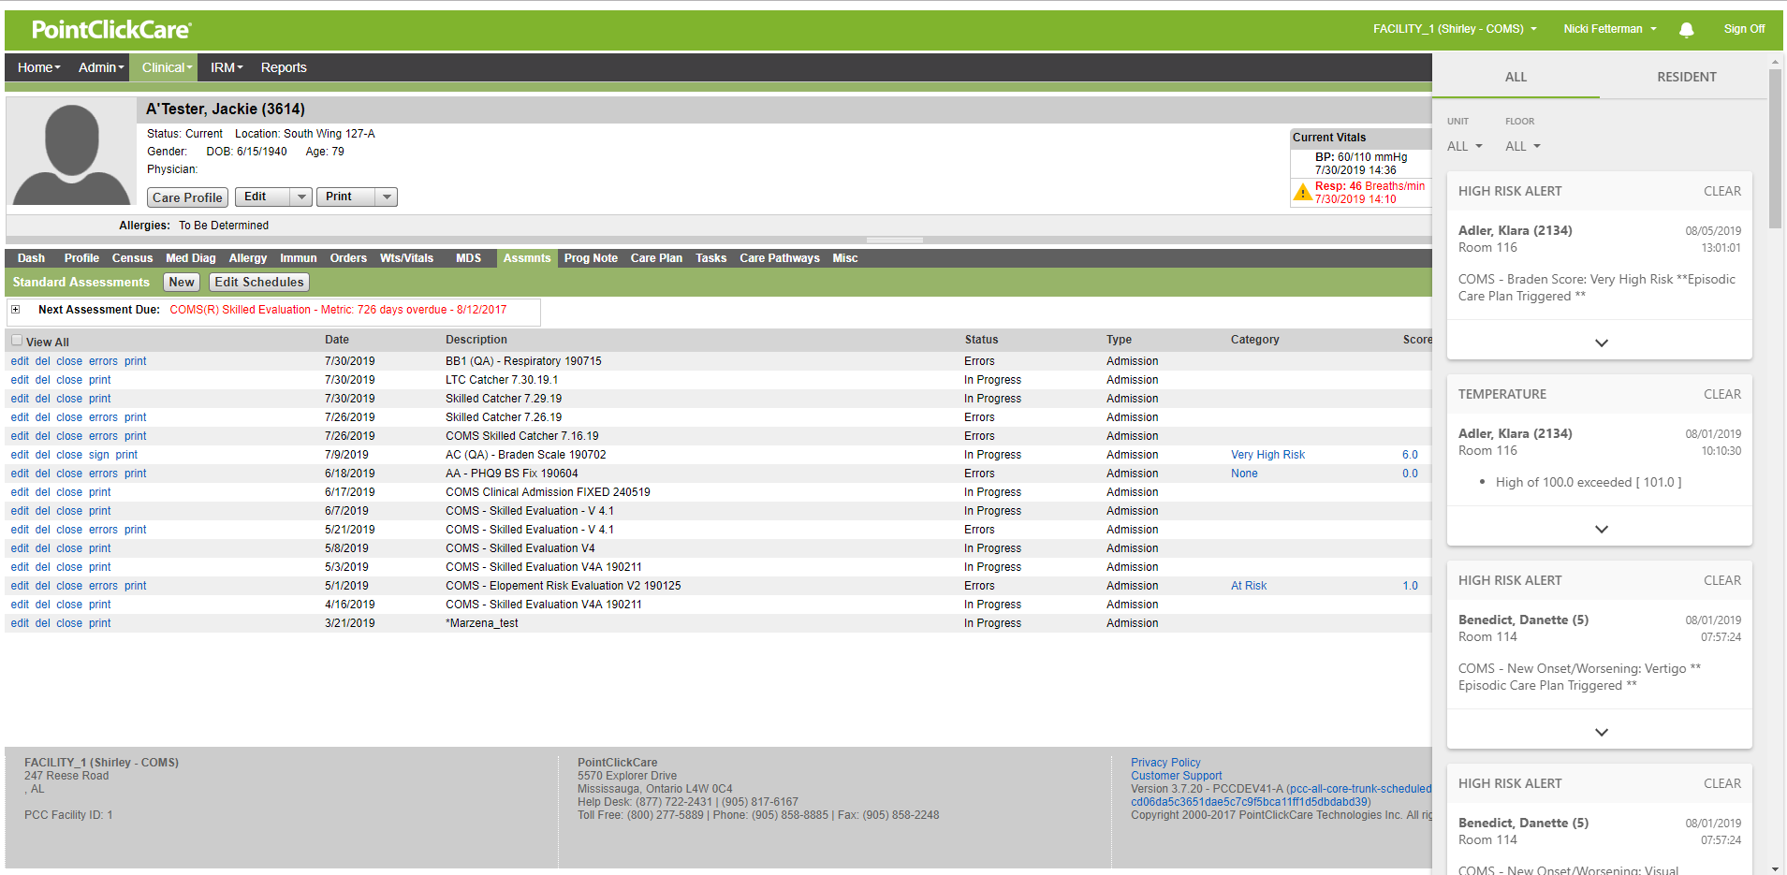

Adler, Klara (Braden) = Stella Smith

Adler, Klara (temp) = Case, Don

Screen 3:

Lay onto background from screen 1.

Make edits to patient names for alerts from screen 2

